CPM Verification Plan
Project: Configurable Packet Modifier (CPM)
Author: Assaf Afriat
Date: 2026-02-01
Version: 1.0
Status: Planning Phase

Phase 1 - Requirements & Stakeholder Analysis
Before developing the verification plan, the following questions were identified for clarification with relevant stakeholders. Understanding these requirements ensures alignment between the design specification and verification approach.
Digital Design Team - Questions
- Fixed vs. Variable Latency: According to the specification, latency is mode-dependent (0-2 cycles). Does each MODE always result in a fixed latency (PASS=0, XOR=1, ADD=2, ROT=1), or can it vary dynamically based on pipeline state?
- Configuration Timing: If the MODE or PARAMS registers are updated while in_valid is high and a packet is being accepted, does the DUT apply the new configuration to the current packet immediately, or is the configuration captured at the moment of acceptance (in_fire)?
- ROT_AMT Parameter: The ROT mode performs a left rotation, but ROT_AMT is defined as a localparam in the RTL (fixed at 4). Is this intentionally fixed, or should it be configurable via a register field?
- Counter Invariant Timing: The invariant COUNT_OUT + DROPPED_COUNT == COUNT_IN - at what point in simulation is this guaranteed to hold? Only when STATUS.BUSY = 0 (pipeline empty)?
Firmware/Software Team - Questions
- Counter Monitoring: The DROPPED_COUNT register tracks discarded packets. Will your drivers poll this register regularly, or do you expect hardware notification (interrupt) when packets are dropped?
- Soft Reset Behavior: In what scenarios do you plan to use the SOFT_RST bit in the CTRL register? Should the pipeline flush completely, and should counters reset to zero?
- Counter Overflow: What is the expected behavior when COUNT_IN, COUNT_OUT, or DROPPED_COUNT overflow their 32-bit range? Standard wrap-around or saturation?
System Architect - Questions
- Traffic Patterns: What is the expected distribution between different modes? Do you anticipate long bursts of single-mode traffic or frequent mode switches? This affects our randomized test constraints.
- Backpressure Scenarios: If the downstream component fails (permanently low out_ready), how should the CPM behave after its internal 2-slot buffer fills? Block input indefinitely or signal error?
- Opcode Usage: Are certain opcodes reserved or more frequently used in the system? This affects our coverage bin weighting strategy.
Board Design Team - Questions
- Clock and Reset: Are there specific power-up sequencing requirements for clk and rst signals that we should model to ensure the DUT initializes correctly in simulation?

Phase 2 - Verification Plan (vPlan) Development

2.1 Scope Definition
In Scope
- Data Path Functionality: Verification of all four transformation modes (PASS, XOR, ADD, ROT). Validating that out_payload matches the expected result based on in_payload and the PARAMS register values.
- Register Functionality: Validating all 8 registers (CTRL, MODE, PARAMS, DROP_CFG, STATUS, COUNT_IN, COUNT_OUT, DROPPED_COUNT). Verifying that register writes correctly configure DUT behavior and reads return accurate values.
- Streaming Protocol: Validation of the CpmStreamIf interface using valid/ready handshake semantics. Testing backpressure handling when out_ready is deasserted.
- Packet Drop Mechanism: Verification that packets with opcodes matching DROP_CFG.DROP_OPCODE are discarded when DROP_CFG.DROP_EN is set, and that DROPPED_COUNT increments correctly.
- Reset Compliance: Verifying the DUT enters a known state after hardware reset (rst), and that SOFT_RST in CTRL register functions correctly to clear counters and pipeline state.
- Counter Invariant: Verification that COUNT_IN == COUNT_OUT + DROPPED_COUNT holds when STATUS.BUSY = 0.
Out of Scope
- Gate-level timing and physical verification
- Register bus protocol edge cases (focus is on functional behavior)
- Performance/throughput measurement
- Multi-beat packets (DUT is single-beat only per specification)

2.2 Verification Strategy
2.2.1 Methodology
- UVM 1.1d Framework: Modular, reusable testbench architecture following UVM best practices
- Dual-Agent Architecture: Separate CpmPacketAgent for streaming interface and CpmRegAgent for register configuration
- RAL Integration: CpmRegModel with CpmRegAdapter for register abstraction, enabling portable test sequences
- Self-Checking: CpmScoreboard with CpmRefModel for automatic comparison of expected vs. actual outputs

2.2.2 Stimulus Strategy
Constrained Random Verification:
- CpmPacketTxn: Randomized m_id, m_opcode, m_payload within valid ranges
- Timing variation: Random inter-packet delays and backpressure patterns
- Mode switching: Dynamic configuration changes during traffic
Sequence Hierarchy:
Sequence | File Location | Purpose
CpmTopVirtualSeq | sequences/virtual/ | Orchestrates complete 8-step test flow
CpmConfigSeq | sequences/ral/ | RAL-based register configuration
CpmBaseTrafficSeq | sequences/packet/ | Random packet generation
CpmStressSeq | sequences/packet/ | Burst traffic patterns
CpmDropSeq | sequences/packet/ | Targeted drop testing
CpmCoverageTrafficSeq | sequences/packet/ | Coverage-directed traffic (factory override target)

2.2.3 Checking Strategy
Scoreboard Architecture (CpmScoreboard):
- CpmRefModel computes expected output based on mode captured at input acceptance time (m_mode_at_accept)
- Input packets stored in expected queue with transformation prediction
- Output packets matched by m_id + m_opcode key
- Drop tracking reconciled against DROPPED_COUNT register
Reference Model Transformations (CpmRefModel):
PASS: payload_out = payload_in (unchanged)
XOR: payload_out = payload_in ^ PARAMS.MASK (bitwise XOR)
ADD: payload_out = payload_in + PARAMS.ADD_CONST (addition with wrap)
ROT: payload_out = {payload_in[11:0], payload_in[15:12]} (rotate left by 4)

Protocol Assertions (SVA in CpmStreamIf):
Assertion | Description
p_input_stability | Input signals must remain stable when in_valid=1 and in_ready=0
p_output_stability | Output signals must remain stable when out_valid=1 and out_ready=0
p_bounded_liveness | Output must appear within latency bound (disabled for dropped packets)

2.3 Metrics for Success (Exit Criteria)

2.3.1 Functional Coverage Targets
Coverpoint | Target | Description
cp_mode | 100% | All 4 modes exercised
cp_opcode | 90%+ | All 16 opcodes (0-15)
cp_mode_opcode | 80%+ | 64 combinations (MODE x OPCODE)
cp_drop | Hit | Drop event exercised
cp_stall | Hit | Backpressure stall exercised

2.3.2 Code Coverage Targets
Metric | Target
Statement Coverage | 95%+
Branch Coverage | 90%+
Expression Coverage | 90%+
Condition Coverage | 80%+
Toggle Coverage | 50%+
Total DUT Coverage | 85%+

2.3.3 Error-Free Execution
- Zero UVM_ERROR or UVM_FATAL messages
- All SVA assertions pass (0 violations)
- Scoreboard: 0 mismatches between expected and actual
- Counter invariant verified after each test phase

Phase 3 - Testbench Architecture

3.1 Architecture Block Diagram
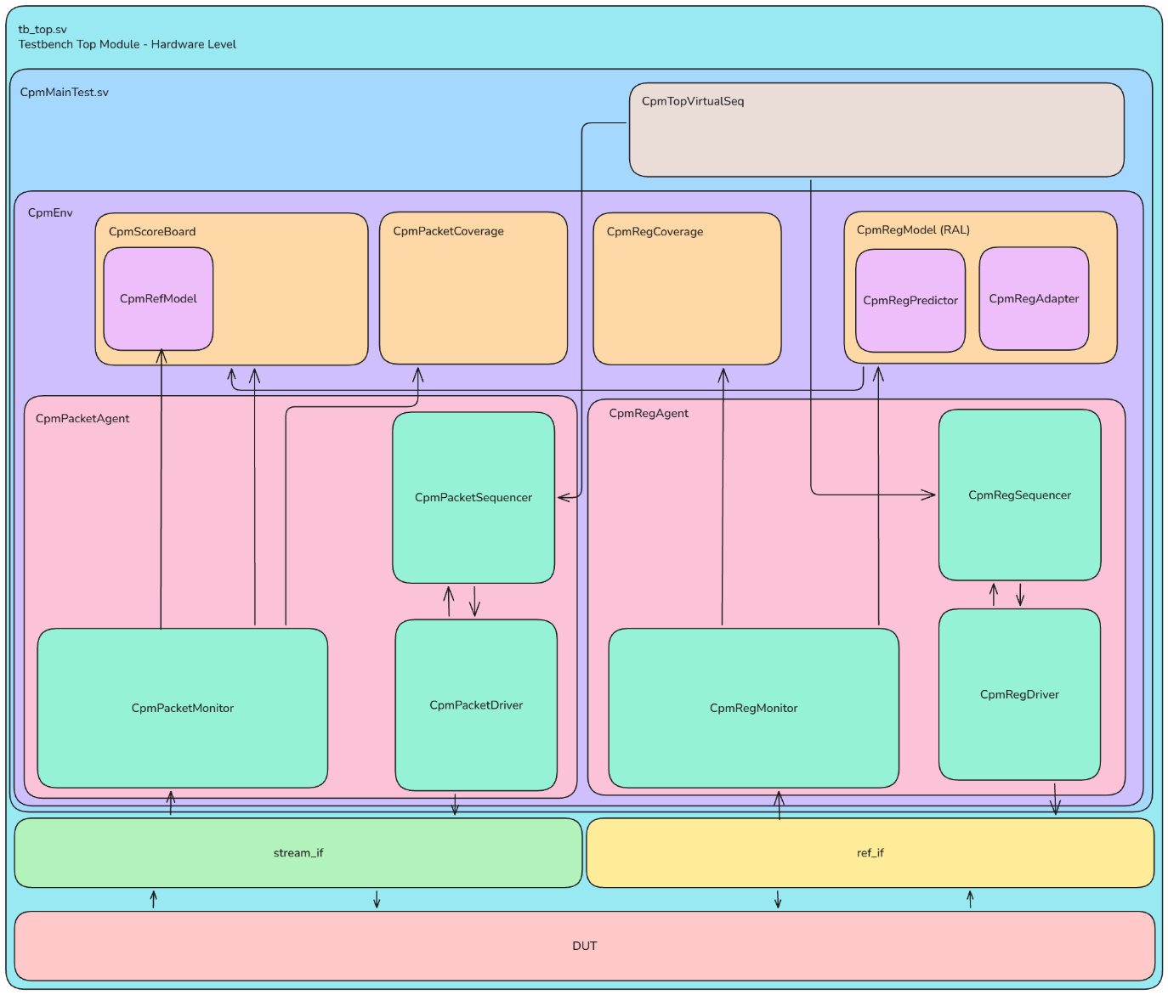

3.2 Transaction Definitions
CpmPacketTxn (Packet Transaction)
Field | Type | Description
m_id | rand bit [3:0] | Packet identifier for tracking through pipeline
m_opcode | rand bit [3:0] | Opcode for drop mechanism comparison
m_payload | rand bit [15:0] | Data payload for transformation
m_mode_at_accept | cpm_mode_e | Mode captured at input acceptance time
m_mask_at_accept | bit [15:0] | MASK value at input acceptance
m_add_const_at_accept | bit [15:0] | ADD_CONST value at input acceptance
m_timestamp | time | Timestamp for latency measurement
m_expected_payload | bit [15:0] | Expected output (for scoreboard comparison)
CpmRegTxn (Register Transaction)
Field | Type | Description
m_addr | rand bit [7:0] | Register address (0x00-0x1C)
m_wdata | rand bit [31:0] | Write data
m_rdata | bit [31:0] | Read data (response from DUT)
m_write_en | rand bit | 1 = Write operation, 0 = Read operation

3.3 RAL Integration
RAL Flow:
- CpmConfigSeq calls m_reg_model.m_mode.write(status, value)
- CpmRegAdapter.reg2bus() converts RAL request to CpmRegTxn
- CpmRegDriver drives signals on CpmRegIf
- CpmRegMonitor captures transaction from bus
- uvm_reg_predictor updates RAL mirror via bus2reg()
RAL Register Map (CpmRegModel)
Instance | Address | Access | Fields | Description
m_ctrl | 0x00 | RW | ENABLE[0], SOFT_RST[1] | Control register
m_mode | 0x04 | RW | MODE[1:0] | Operation mode
m_params | 0x08 | RW | MASK[15:0], ADD_CONST[31:16] | Transformation parameters
m_drop_cfg | 0x0C | RW | DROP_EN[0], DROP_OPCODE[7:4] | Drop configuration
m_status | 0x10 | RO | BUSY[0] | Pipeline status
m_count_in | 0x14 | RO | COUNT[31:0] | Input packet counter
m_count_out | 0x18 | RO | COUNT[31:0] | Output packet counter
m_dropped_count | 0x1C | RO | COUNT[31:0] | Dropped packet counter

3.4 Component Summary
Environment Components
Component | File | Description
CpmEnv | env/CpmEnv.sv | Top environment container
CpmPacketAgent | agent/CpmPacketAgent.sv | Stream interface agent (driver + monitor + sequencer)
CpmRegAgent | agent/CpmRegAgent.sv | Register bus agent (driver + monitor + sequencer)
CpmScoreboard | scoreboard/CpmScoreboard.sv | Packet comparison checker with expected queue
CpmRefModel | scoreboard/CpmRefModel.sv | Golden reference model for transformations
CpmPacketCoverage | coverage/CpmPacketCoverage.sv | Packet functional coverage collector
CpmRegCoverage | coverage/CpmRegCoverage.sv | Register access coverage collector
Tests
Test | File | Description
CpmBaseTest | tests/CpmBaseTest.sv | Common test base class
CpmMainTest | tests/CpmMainTest.sv | Full flow with factory override + callback demo
CpmSmokeTest | tests/CpmSmokeTest.sv | Quick sanity check
CpmRalResetTest | tests/CpmRalResetTest.sv | RAL reset value verification

Mandatory UVM Features Implementation
Feature | Implementation
RAL (Register Abstraction Layer) | CpmRegModel + CpmRegAdapter + uvm_reg_predictor
Virtual Sequence | CpmTopVirtualSeq with 8-step orchestration flow
Factory Override | CpmBaseTrafficSeq → CpmCoverageTrafficSeq in CpmMainTest
Callbacks | CpmBasePacketCb with pre_drive/post_drive hooks
Functional Coverage | cg_packet covergroup in CpmPacketCoverage
SVA Assertions | p_input_stability, p_output_stability, p_bounded_liveness

Phase 4 - Coverage Plan Development

4.1 Packet Coverage (cg_packet in CpmPacketCoverage.sv)
# | Name | Type | Definition
1 | cp_mode | Coverpoint | Bins: mode_pass, mode_xor, mode_add, mode_rot
2 | cp_opcode | Coverpoint | 16 auto-bins for opcodes 0-15
3 | cp_mode_opcode | Cross | MODE × OPCODE (64 combinations, target 80%+)
4 | cp_drop | Coverpoint | Bins: drop_hit (packet dropped), no_drop
5 | cp_stall | Coverpoint | Bins: stall_hit (backpressure observed), no_stall

4.2 Register Coverage (cg_register in CpmRegCoverage.sv)
# | Name | Type | Definition
1 | cp_addr | Coverpoint | 8 bins for register addresses (0x00, 0x04, 0x08, 0x0C, 0x10, 0x14, 0x18, 0x1C)
2 | cp_op | Coverpoint | Bins: read, write
3 | cp_addr_op | Cross | Address × Operation (16 combinations)

Coverage Bin Definitions
Mode Coverage (cp_mode): Four explicit bins ensure each transformation mode is exercised at least once during simulation. This is critical for verifying all data path transformations.
Opcode Coverage (cp_opcode): Sixteen auto-generated bins cover the full range of 4-bit opcode values (0x0 through 0xF). This ensures traffic diversity and validates the drop mechanism across all possible opcodes.
Cross Coverage (cp_mode_opcode): The cross product of mode and opcode creates 64 combination bins (4 modes × 16 opcodes). The target of 80%+ ensures comprehensive interaction testing between modes and opcodes.
Drop Coverage (cp_drop): Two bins track whether the drop mechanism was triggered. The drop_hit bin confirms the drop functionality was exercised; no_drop confirms normal packet flow.
Stall Coverage (cp_stall): Two bins track backpressure scenarios. The stall_hit bin confirms the DUT was tested under backpressure conditions where out_ready was deasserted while out_valid was high.

Phase 5 - Detailed Test Case Design

Test 1: Basic Transformation & RAL Consistency
Goal: Verify data transformation and RAL mirror synchronization.
Steps:
- CpmConfigSeq: Write m_mode = XOR, m_params = {ADD_CONST, MASK=0xAAAA}
- Send CpmPacketTxn with m_payload = 0x5555
- Wait for output (1 cycle latency for XOR mode)
- CpmScoreboard: Verify output = 0xFFFF (0x5555 XOR 0xAAAA)
- RAL mirror check: m_reg_model.m_mode.get() matches written value
Pass Criteria: Output matches expected, RAL mirror is synchronized.

Test 2: All Modes Sweep
Goal: Verify all 4 transformation modes produce correct results.
Steps:
- For each mode in {PASS, XOR, ADD, ROT}:
  - Configure via CpmConfigSeq
  - Send 10+ packets via CpmBaseTrafficSeq
  - CpmRefModel predicts expected output
  - CpmScoreboard verifies all packets match
Pass Criteria: All packets in all modes match expected output.

Test 3: Drop Mechanism & Counter Accuracy
Goal: Verify DROP_CFG functionality and DROPPED_COUNT counter.
Steps:
- Configure m_drop_cfg: DROP_EN=1, DROP_OPCODE=0x8
- CpmDropSeq: Send packets with m_opcode=0x8 (should drop)
- Send packets with other opcodes (should pass)
- Verify dropped packets do not appear at output
- RAL read m_dropped_count, verify matches actual drop count
Pass Criteria: Dropped packets not at output, counter accurate.

Test 4: Backpressure & Pipeline Recovery
Goal: Verify out_ready backpressure handling and signal stability.
Steps:
- Configure MODE = ADD via CpmConfigSeq
- CpmStressSeq: Start continuous packet burst
- Deassert out_ready for 20+ cycles
- Verify in_ready drops (buffer full condition)
- Reassert out_ready
- Verify no data loss, correct packet sequence maintained
- SVA p_output_stability passes (no signal changes during stall)
Pass Criteria: No data loss, SVA passes, correct ordering.

Test 5: Counter Invariant Verification
Goal: Verify COUNT_IN == COUNT_OUT + DROPPED_COUNT holds.
Steps:
- Enable drop for specific opcode
- Send mixed traffic (some dropped, some passed)
- Poll m_status.m_busy until 0 (pipeline empty)
- RAL read: m_count_in, m_count_out, m_dropped_count
- Verify invariant: COUNT_IN == COUNT_OUT + DROPPED_COUNT
Pass Criteria: Counter invariant holds after pipeline drain.

Test 6: RAL Reset Verification (MANDATORY - CpmRalResetTest)
Goal: Verify all registers have correct reset values per specification.
Steps:
- Apply hardware reset (rst = 1)
- Execute uvm_reg_hw_reset_seq on m_reg_model
- Sequence reads each register and compares against RAL-defined reset values
- Verify each register matches specification reset value
Pass Criteria: All registers match reset values, no UVM_ERROR.

Test 7: Full Virtual Sequence Flow (MANDATORY - CpmMainTest)
Goal: Demonstrate all mandatory UVM features in a comprehensive test.
Steps (CpmTopVirtualSeq 8-step flow):
- Reset Wait: Wait for rst deassert
- Configure: CpmConfigSeq programs registers via RAL
- Traffic: CpmBaseTrafficSeq sends 200+ packets
- Reconfigure: Cycle all 4 modes with traffic per mode
- Stress: CpmStressSeq burst traffic with backpressure
- Drop Test: CpmDropSeq targeted drop verification
- Readback: RAL read all counters
- End Check: Verify counter invariant
Mandatory Features Demonstrated:
- Factory Override: CpmBaseTrafficSeq::type_id::set_type_override(CpmCoverageTrafficSeq::get_type())
- Callback: CpmPacketStatsCb registered on CpmPacketDriver
Pass Criteria: All 8 steps complete, 0 errors, factory override logged, callback stats printed.

Phase 6 - Closure & Reporting Strategy

6.1 Key Performance Indicators (KPIs)
KPI | Target | Measurement
Test Pass Rate | 100% | Zero UVM_ERROR or UVM_FATAL in simulation log
Scoreboard Mismatches | 0 | All expected vs actual comparisons pass
SVA Violations | 0 | All assertions pass throughout simulation
Functional Coverage | All targets met | Coverage report meets defined targets
Code Coverage | 85%+ total | DUT code coverage report

6.2 Verification Sign-off Criteria
Functional Coverage Sign-off
Metric | Target | Status
cp_mode | 100% | [ ] Pass
cp_opcode | 90%+ | [ ] Pass
cp_mode_opcode | 80%+ | [ ] Pass
cp_drop | Hit | [ ] Pass
cp_stall | Hit | [ ] Pass

Code Coverage Sign-off
Metric | Target | Status
Statement Coverage | 95%+ | [ ] Pass
Branch Coverage | 90%+ | [ ] Pass
Total DUT Coverage | 85%+ | [ ] Pass

Mandatory Features Checklist
Feature | Verification Method | Status
RAL | CpmRalResetTest passes, all registers accessible | [ ] Complete
Virtual Sequence | CpmTopVirtualSeq completes 8-step flow | [ ] Complete
Factory Override | Log confirms override in CpmMainTest | [ ] Complete
Callbacks | CpmBasePacketCb hooks execute, stats printed | [ ] Complete
SVA Assertions | 0 violations for all assertions | [ ] Complete
Functional Coverage | Report meets all targets | [ ] Complete
Counter Invariant | Verified via RAL at end of each test | [ ] Complete

6.3 Deliverables
Deliverable | Location | Description
Verification Plan | deliverables/CPM_Verification_Plan.docx | This document
UVM Testbench | verification/ | Complete environment source code
Test Suite | tests/ | CpmSmokeTest, CpmMainTest, CpmRalResetTest
Coverage Report | coverage/ | Functional and code coverage results
Bug Reports | tracking/bug_tracker.csv | All discovered issues and resolutions
Sign-off Document | docs/SIGNOFF.md | Final verification sign-off

6.4 Risk Assessment & Mitigation
Risk | Impact | Mitigation Strategy
Spec ambiguity (ROT_AMT, counter timing) | Medium | Document assumptions in bug_tracker, clarify with design team
DUT bugs blocking progress | High | Track in bug_tracker.csv, prioritize critical issues
Coverage gaps | Medium | Add directed sequences, use coverage-driven traffic
Timing issues in scoreboard | Medium | Capture config at acceptance time, drain pipeline before checks

End of Document
CPM Verification Plan | Version 1.0
Author: Assaf Afriat | Date: 2026-02-01
This verification plan is written prior to implementation and describes the planned approach, targets, and expected outcomes for the CPM verification project.

